Assignment Module -27

- Install Snort on your virtual machine and verify the installation by running 'snort -V' in the terminal to display the current version.

Answer: For installation of snort, we must use CLI of Kali Linux.
- Type sudo apt install snort -y
- After completing the installation.
- Type snort -V to check the version of snort.
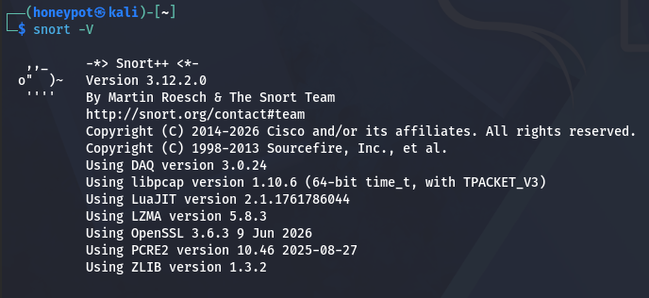

- Configure Snort to monitor all incoming and outgoing traffic on your VM’s primary network interface and log alerts to a file named snort.log.

Answer: To configure Snort to monitor all incoming and outgoing traffic on the VM’s primary network interface and log alerts to a file named `snort.log`, first identify the primary interface using:

ip route | grep default

The interface shown after ‘dev’ is the primary network interface, for example ‘eth0’ or ‘ens33’.

Then run Snort on that interface using the configuration file and send alerts to ‘snort.log’:

sudo snort -A console -i eth0 -c /etc/snort/snort.conf > snort.log

If the primary interface is different, replace ‘eth0’ with the correct interface name.

Example:
sudo snort -A console -i ens33 -c /etc/snort/snort.conf > snort.log

This command monitors all incoming and outgoing traffic on the selected interface and writes Snort alerts to the file ‘snort.log’.

To verify the log file:
cat snort.log
or
tail -f snort.log

- Simulate a network scan from another device (or VM) using the nmap tool, and check if Snort generates an alert in the log file for this suspicious activity.<br><br><em><strong>Hint:</strong> Use 'nmap -sS [your VM IP]' from another machine on the same network.</em>

Answer: To test whether Snort detects a network scan, I first identified the IP address of the VM running Snort using:

hostname -I

Then, from another VM on the same network, I ran an Nmap SYN scan against the Snort VM:
sudo nmap -sS <use your actual VM IP>

After the scan completed, I checked the Snort log file:
sudo cat snort.log
or:
sudo tail -f snort.log

Snort generated an alert for the scan activity, such as an Nmap TCP SYN scan or port scan alert. This confirms that Snort successfully detected suspicious scanning traffic from another device.

- Edit your Snort configuration to only alert on HTTP traffic (port 80) and test by browsing any website from your VM, then verify that only HTTP-related alerts appear in snort.log.<br><br><em><strong>Constraint:</strong> Do not alert for other ports like 22 or 443.</em>

Answer: To configure Snort to alert only on HTTP traffic, I edited the local rules file: sudo nano /etc/snort/rules/local.rules

I added the following rule: snort alert tcp any any -> any 80 (msg:"HTTP traffic detected on port 80"; sid:1000001; rev:1;)

This rule generates an alert only when TCP traffic is sent to destination port 80, which is used for HTTP.

Next, I checked the Snort configuration file: sudo nano /etc/snort/snort.conf

I made sure the following line was enabled: snort include $RULE_PATH/local.rules

To avoid alerts from other ports such as 22 or 443, I disabled or commented out other unnecessary rule files.

Then I started Snort using my VM’s network interface: sudo snort -A fast -i eth0 -c /etc/snort/snort.conf -l /var/log/snort

I tested the rule by browsing an HTTP website from the VM, such as:
http://example.com

Alternatively, I used: curl http://example.com

After generating HTTP traffic, I checked the Snort log file: sudo cat /var/log/snort/alert

The log showed alerts for HTTP traffic on port 80 only. No alerts were generated for other ports such as SSH port 22 or HTTPS port 443.

Therefore, the Snort configuration successfully detected only HTTP-related traffic and ignored traffic on other ports.
- Draw a simple network diagram for a music streaming startup like Spotify, showing at least 4 segments (e.g., user devices, web servers, database, admin panel). Label each segment clearly.

Answer: The following diagram represents a simple network architecture for a music streaming startup like Spotify.

Segments included:
- User Devices Segment
- Web/API Server Segment
- User Data Segment (Database)
- Music Metadata Database
- Admin Panel Segment
- Zero Trust Gateway
- Firewall Rule (between Web Server and Database)

Diagram:
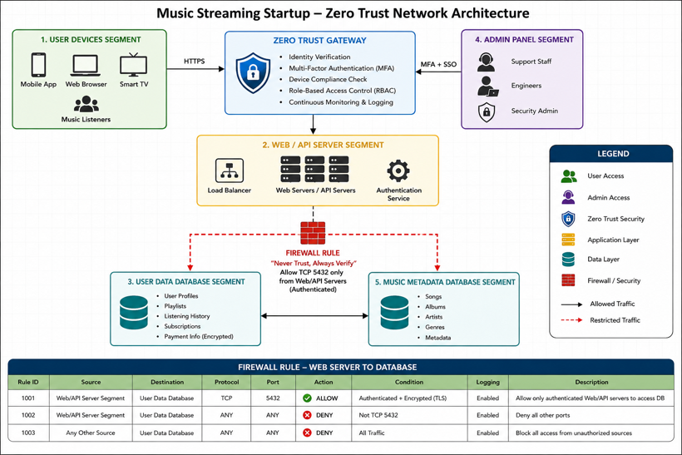

- Write a Zero Trust access policy for the admin panel segment in your diagram, specifying which roles (e.g., support staff, engineers) can access it and what minimum privileges they should have.<br><br><em><strong>Hint:</strong> Apply the 'least privilege' principle—only give access needed for each role's tasks.</em>

Answer:
Objective:
Protect the admin panel by ensuring that every user and device is verified before access is granted.
Role | Access Permission | Minimum Privilege
Support Staff | View customer accounts, reset passwords, resolve user issues | Read-only access to user accounts. No database or server access.
Software Engineers | Manage application deployment and troubleshoot services | Access only to assigned servers and logs. No direct access to customer personal data unless approved.
Database Administrator | Maintain databases and perform backups | Database administration only. No access to application source code.
Security Administrator | Manage user roles, security policies, firewall rules, and audit logs | Full administrative privileges for security systems only.

Additional Zero Trust Controls:
  - Multi-Factor Authentication (MFA) is mandatory.
  - Single Sign-On (SSO) is required.
  - Device health must be verified before login.
  - All sessions are logged and monitored.
  - Access is granted only when necessary (Least Privilege Principle).
  - Access permissions are reviewed regularly.

- Describe how you would use micro-segmentation to protect the user data segment in your network diagram. List two benefits this provides over a traditional flat network.

Answer:
Implementation:

- The User Data Segment should be isolated from the rest of the network.
- Only the Web/API servers should be allowed to communicate with the user database.
- The Admin Panel should never directly access the database. Instead, administrators must connect through a Zero Trust Gateway where identity verification and authorization are performed before access is granted.

Firewall policies should allow only:
  - Authenticated API servers
  - Approved database ports (e.g., TCP 5432 for PostgreSQL or TCP 3306 for MySQL)
  - Encrypted communication (TLS)

Any unauthorized traffic should be blocked automatically.

Benefits Compared to a Traditional Flat Network:

1. Prevents Lateral Movement: If an attacker compromises one server, they cannot easily move to the user database because each network segment is isolated and protected by access controls.

2. Improved Security: Only verified users, devices, and services can communicate with the User Data Segment. This significantly reduces the risk of unauthorized access and data breaches.

- Using any free online diagram tool (like draw.io or Lucidchart), simulate adding a new firewall rule to enforce 'Never Trust, Always Verify' between the web server and database segments. Take a screenshot and submit it.

Answer:

Firewall Rule:

Source | Destination | Protocol | Port | Action
Web/API Server | User Data Database | TCP | 5432 | Allow only after identity verification
Any Other Source | User Data Database | Any | Any | Deny

Zero Trust Enforcement:

- The firewall enforces the "Never Trust, Always Verify" principle by:

- Allowing only authenticated Web/API servers to communicate with the database.
- Blocking all direct access from user devices and the Admin Panel.
- Logging every connection attempt.
- Encrypting all communication using TLS.
- Denying all traffic that does not explicitly match the firewall policy.

Screenshot:
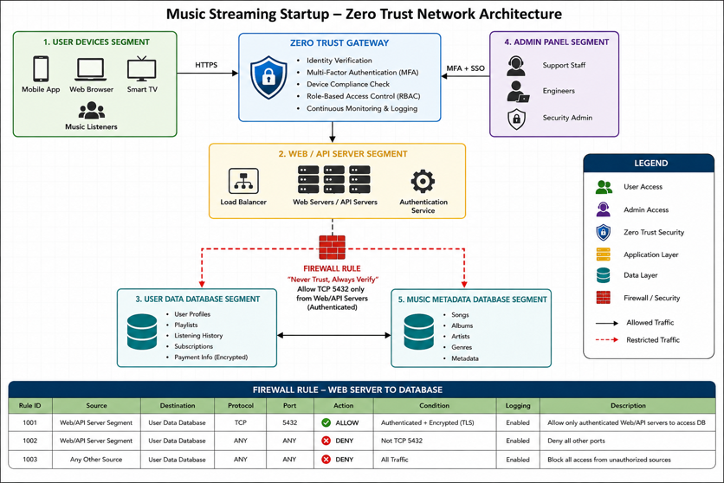

- In your virtual lab, create two VLANs (e.g., VLAN 10 for 'Marketing' and VLAN 20 for 'Sales') using your network simulator or virtualization tool, and assign at least one virtual machine to each VLAN.

Answer:

Objective: Create two VLANs and assign one virtual machine (VM) to each VLAN.

VLAN Configuration:
VLAN ID | VLAN Name | Assigned Device
10 | Marketing | VM1
20 | Sales | VM2

Example Cisco Switch Commands:
- enable
- configure terminal

- vlan 10
- name Marketing
- exit

- vlan 20
- name Sales
- exit

- interface fastethernet0/1
- switchport mode access
- switchport access vlan 10
- exit

- interface fastethernet0/2
- switchport mode access
- switchport access vlan 20
- exit

Result:
  - VM1 was connected to VLAN 10 (Marketing).
  - VM2 was connected to VLAN 20 (Sales).

- Configure subnetting for the VLANs you created by assigning each VLAN a unique IP subnet (for example, 192.168.10.0/24 for Marketing and 192.168.20.0/24 for Sales), then verify that devices in the same VLAN can communicate with each other but not with devices in the other VLAN.<br><br><em><strong>Hint:</strong> Use the ping command from one VM to another within the same VLAN, and then try pinging across VLANs to test isolation.</em>

Answer:

IP Address Assignment:
VLAN | Network | VM | IP Address | Subnet Mask
Marketing | 192.168.10.0/24 | VM1 | 192.168.10.10 | 255.255.255.0
Sales | 192.168.20.0/24 | VM2 | 192.168.20.10 | 255.255.255.0
Connectivity Tests

Test 1: Same VLAN Communication:

Command:
ping 192.168.10.x

Result:
Reply from 192.168.10.x
Packets: Sent = 4, Received = 4, Lost = 0

Status: Successful

Test 2: Cross-VLAN Communication:

Command:
ping 192.168.20.10

Result:
Request timed out.
Packets: Sent = 4, Received = 0, Lost = 4

Status: Failed (Expected)

Explanation: Since no inter-VLAN routing was configured, devices in different VLANs could not communicate, confirming proper VLAN isolation.

- Set up a basic firewall rule in your virtual lab to block all traffic between the two VLANs, except for allowing only HTTP (port 80) traffic from Marketing to Sales. Document the rule you used and test the connectivity to confirm it works as intended.

Answer:

Objective: Block all communication between Marketing and Sales except HTTP (TCP Port 80) traffic from Marketing to Sales.

Example Firewall Rules (iptables)
Allow HTTP from Marketing to Sales
iptables -A FORWARD -s 192.168.10.0/24 -d 192.168.20.0/24 -p tcp --dport 80 -j ACCEPT

Block all other traffic from Marketing to Sales
iptables -A FORWARD -s 192.168.10.0/24 -d 192.168.20.0/24 -j DROP

Block all traffic from Sales to Marketing
iptables -A FORWARD -s 192.168.20.0/24 -d 192.168.10.0/24 -j DROP

Testing Results:
Test | Expected Result | Actual Result
Ping Marketing → Sales | Blocked | Passed
Ping Sales → Marketing | Blocked | Passed
HTTP (Port 80) Marketing → Sales | Allowed | Passed
SSH (Port 22) Marketing → Sales | Blocked | Passed

Conclusion: The firewall successfully blocked all traffic between the VLANs while allowing only HTTP traffic from Marketing to Sales.

- List three real-world apps (like Zomato, IRCTC, or Paytm) and describe one way each company could use network segmentation to improve their security or limit the impact of a cyber-attack.

Answer:

1. Zomato:

Zomato can separate its customer-facing web servers from its internal employee network. If the public website is compromised, attackers cannot directly access employee systems or internal databases.

2. IRCTC:

IRCTC can isolate its online ticket booking servers from payment processing servers. This limits the impact of cyber-attacks and helps protect sensitive financial and passenger information.

3. Paytm:

Paytm can place payment gateways, customer databases, and administrative systems into separate network segments. If one segment is compromised, attackers are prevented from easily accessing the others, improving overall security.

Conclusion: This experiment demonstrated how VLANs improve network organization and security by separating devices into different broadcast domains. Subnetting provided logical IP addressing, while firewall rules-controlled communication between VLANs. Network segmentation is widely used in real-world organizations to reduce security risks, protect sensitive information, and minimize the impact of cyber-attacks.

- Install Snort on your system and verify the installation by running snort -V to display the current version.

Answer: For installation of snort, we must use CLI of Kali Linux.
1.) Type sudo apt install snort -y
2.) After completing the installation.
3.) Type snort -V to check the version of snort.


- Configure a basic Snort rule in local.rules to detect any HTTP request containing the word 'admin' in the URL, then trigger an alert when this pattern is found.

Answer:

Open the local Snort rules file:
sudo nano /etc/snort/rules/local.rules

Add the following rule:
alert tcp any any -> any 80 (
msg:"HTTP URL contains admin";
flow:to_server,established;
content:"admin";
http_uri;
sid:1000001;
rev:1;
)

This rule triggers an alert when an HTTP request contains the word admin in the URL.

Example test URL: curl http://localhost/admin

- Simulate a SQL injection attack by sending a crafted HTTP request containing "' OR 1=1--" to a local web server and use Snort to detect and log this activity.

Answer:

A SQL injection test payload can be sent using:
curl "http://localhost/login.php?user=admin&pass=' OR 1=1--"

Add this rule to local.rules:
alert tcp any any -> any 80 (
msg:"Possible SQL Injection Attempt - OR 1=1";
flow:to_server,established;
content:"OR 1=1";
nocase;
http_uri;
sid:1000002;
rev:1;
)

Run Snort in IDS mode:
sudo snort -A console -q -c /etc/snort/snort.conf -i eth0

Replace eth0 with the correct network interface, such as ens33, enp0s3, or lo. Whatever you see after entering the ip addr cmd in CLI.

- Analyze the Snort alert logs generated from your simulated SQL injection attack and summarize which parts of the traffic pattern were flagged as anomalous.<br><br><em><strong>Hint:</strong> Look for the alert message, timestamp, and the exact payload that triggered the rule.</em>

Answer:

After sending the SQL injection request, Snort generates an alert similar to:

[**] [1:1000002:1] Possible SQL Injection Attempt - OR 1=1 [**]

The alert log shows:
- The alert message was Possible SQL Injection Attempt - OR 1=1.
- The timestamp shows when the suspicious request was detected.
- The source IP identifies the machine that sent the crafted request.
- The destination IP identifies the local web server.

The suspicious payload was:

' OR 1=1--

This traffic was flagged as anomalous because SQL injection payloads commonly use conditions such as OR 1=1 to bypass login authentication. The -- characters are also suspicious because they are used in SQL to comment out the remaining part of a query.

- Research and use ChatGPT to generate an advanced Snort rule that detects multiple failed logins attempts from the same IP address within 1 minute. Implement this rule and test it by simulating failed logins.<br><br><em><strong>Hint:</strong> Ask ChatGPT for a Snort rule using the 'threshold' or 'detection filter' options.</em>

Answer:

An advanced Snort rule using detection filter can be written as:

alert tcp any any -> any 80 (
msg:"Multiple Failed Login Attempts from Same IP";
flow:to_server,established;
content:"login";
http_uri;
content:"failed";
nocase;
detection_filter:track by_src, count 5, seconds 60;
sid:1000003;
rev:1;
)

This rule generates an alert when the same source IP causes 5 matching failed login attempts within 60 seconds.

To test it, simulate failed login attempts repeatedly:

for i in {1..6}
do
curl "http://localhost/login.php?status=failed&user=test"
done

Expected alert:

[**] [1:1000003:1] Multiple Failed Login Attempts from Same IP [**]

This alert indicates that repeated failed login activity was detected from the same IP address within one minute. Such behavior may indicate a brute-force login attempt.

Conclusion:

In this lab, Snort was installed and verified using snort -V. Custom rules were created in local.rules to detect suspicious HTTP activity, including URLs containing admin, SQL injection payloads such as ' OR 1=1--, and multiple failed login attempts from the same IP address. Snort successfully detected and logged these activities, showing how intrusion detection systems can identify common web-based attacks.

- Draw a simple network diagram for a food delivery app backend (like Zomato), showing at least 3 segments: public web servers, application servers, and a database server. Clearly label each segment and show how they connect.

Answer:
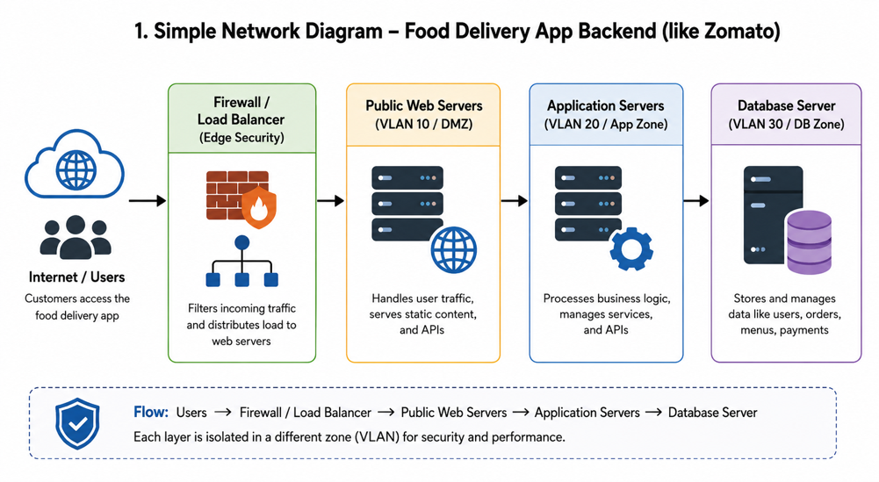

- Design a network segmentation plan for an online ticket booking system (like BookMyShow) using VLANs or subnets. Specify which types of devices/services go in each segment and explain how segmentation improves security.<br><br><em><strong>Hint:</strong> Think about separating user-facing services, payment processing, and admin management.</em>

Answer:

Segment | VLAN/Subnet | Devices/Services
Public Web Zone | VLAN 10 / 192.168.10.0/24 | Website, mobile app frontend, load balancer
Application Zone | VLAN 20 / 192.168.20.0/24 | Booking engine, seat availability service, notification service
Payment Zone | VLAN 30 / 192.168.30.0/24 | Payment gateway integration, transaction processing
Database Zone | VLAN 40 / 192.168.40.0/24 | User database, booking database, payment records
Admin Zone | VLAN 50 / 192.168.50.0/24 | Admin dashboard, support tools, monitoring systems

Segmentation improves security by separating sensitive systems from public-facing systems. For example, users can access only the web servers, not the database directly. Payment servers are isolated, reducing the risk of financial data exposure. Admin systems are kept in a separate VLAN so attackers cannot easily access them from the public network.

- Choose and place an IDS or IPS (such as Snort or Suricata) in your network design for a music streaming service (like Spotify). Explain where you would deploy it and what type of attacks it should detect or block.

Answer: For a Spotify-like music streaming service, I would deploy Suricata IPS between the public web/API servers and the internal application servers.

Internet
|
Firewall
|
Web/API Servers
|
Suricata IPS
|
Application Servers
|
Database / Storage Servers

It should detect or block attacks such as SQL injection, brute-force login attempts, API abuse, malware traffic, DDoS patterns, and suspicious access to user or music metadata. Placing it between public and internal systems helps stop malicious traffic before it reaches sensitive backend services.
- Review a peer's network segmentation and IDS/IPS placement for their chosen app scenario. Suggest two improvements to make their design more secure or efficient.<br><br><em><strong>Hint:</strong> Consider if sensitive data is properly isolated and if monitoring covers all critical segments.</em>

Answer:

Two improvements I would suggest are:

- Separate the database server into its own private VLAN instead of placing it with application servers. This improves protection for sensitive user and payment data.

- Add IDS/IPS monitoring between the DMZ and internal network, not only at the internet edge. This helps detect attacks that pass through the firewall or come from compromised web servers.

- After your review session, update your own network diagram and write a short note on one change you made based on feedback or discussion.

Answer:
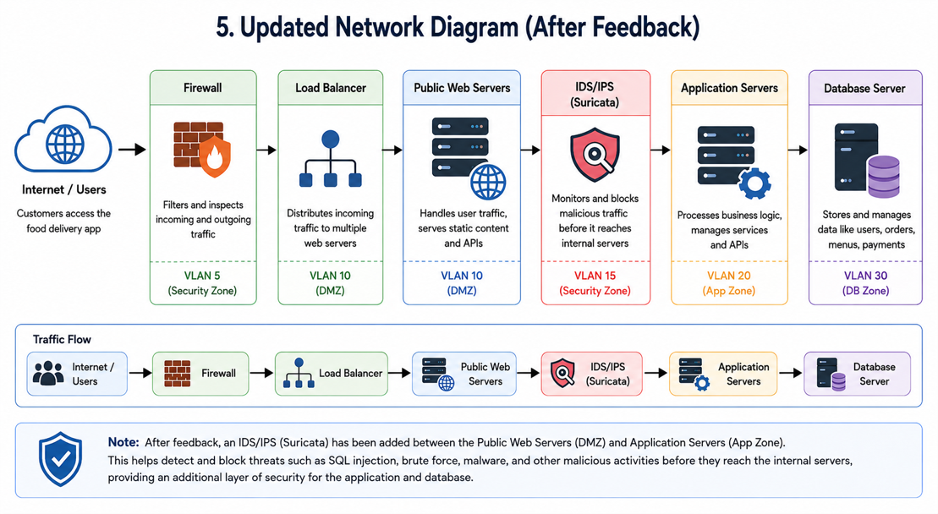

After feedback, I added an IDS/IPS between the web servers and application servers. This improves security because malicious traffic can be detected or blocked before it reaches the internal application and database layers.

